This paper presents the design and implementation of a virtual music store that allows users to browse and purchase musical instruments, accessories, and other related products. The platform also includes a blog section for customer engagement and a user management system. Future developments will incorporate features such as promotional discounts, diverse payment methods, and a shopping cart for enhanced user experience.

Index Terms - Virtual music store, database design, inventory management

I. Introduction

With the rise of e-commerce, virtual stores have become essential for retail businesses. This paper discusses the development of a virtual music store that integrates various features, such as inventory management, blog interaction, and receipt generation. The system allows customers to purchase instruments, accessories, and engage with content through a blog section. Additionally, future enhancements are projected to include promotional features, various payment methods, and a shopping cart system.

II. Methods

The development of the virtual music store involved both front-end application design and back-end database structuring. The database design followed an 8-step process to ensure proper organization and scalability for future growth.

The steps followed for designing the database were:

1. Defining Components:

Identifying the main business functions to be managed by the system, including product management, transaction tracking, and user interactions.

1. Defining Entities:

Key entities were established, including instruments, brands, categories, inventory, receipts, suppliers, users, and accessory products.

1. Defining Attributes per Entity:

Attributes were assigned to each entity. For example, the Instrument entity includes attributes such as instrument ID, name, price, and stock. Similarly, the User entity includes username, password, and role.

1. Defining Relationships Between Attributes:

Relationships between entities were defined to facilitate data flow. For example, an instrument is linked to a brand and category, and receipts track the relationship between users, suppliers, and inventory.

1. Defining Types of Relationships:

Relationships were classified as one-to-one, one-to-many, or many-to-many, depending on the entities involved. For instance, an instrument can belong to one brand but a brand can have many instruments.

1. Entity-relationship diagram:

A visual representation of the relationships between entities was created using an entity-relationship diagram. This step helped to clarify connections between various components, and the diagram was used as a blueprint for the database's structure. The provided diagram (Figure 1) shows how entities like Instrument, Accessory, Inventory, Receipt, and others are related.

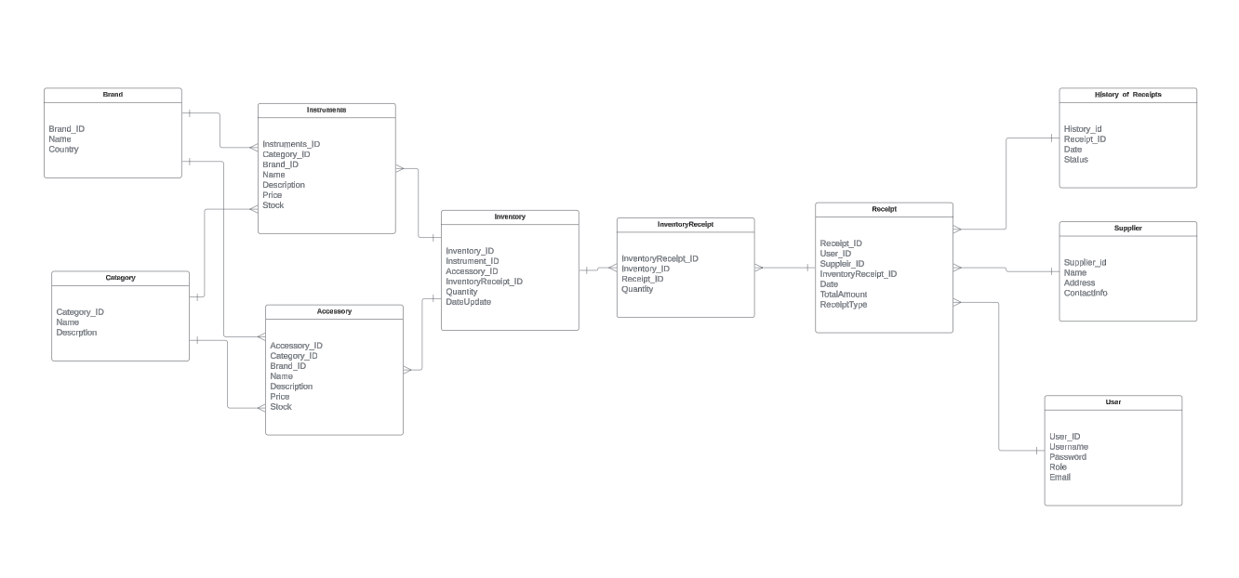

Figure 1

1. Defining data properties:

Identify the type of data each has, plus give specifications to each data for so have a much cleaner database

1. Final Database Design:

A conceptual design was developed, which evolved into the logical design represented in the provided diagram.

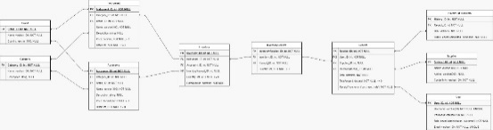

The final database, as depicted in the diagram (Figure 2), shows relationships between core entities such as Instrument, Accessory, Inventory, Receipt, and others. This relational model facilitates efficient product management, inventory tracking, and user transactions.

III. Results

The outcome of this project was a fully functional virtual music store with the ability to handle complex interactions such as product inventory updates, user registration, and the generation of purchase receipts. The relational database efficiently manages inventory data, receipt records, and supplier information, providing a solid backbone for the store’s operations.

The project lays the foundation for future additions such as shopping cart functionality, promotional discounts, and multiple payment options, all of which can be seamlessly integrated into the existing database structure.

IV. Conclusions

This article demonstrates the design of the first module of the application. Following a clear methodology for defining components, entities, attributes and relationships, focusing on the main part of the application which is the generation of an inventory and its classification, receipts and users. As well as planning future improvements, such as the generation of promotions, payment methods, etc.